AUTOMATION TESTING
Task 01
SauceDemo Login & Product Extraction
Python • Selenium WebDriver • Chrome

STUDENT  Logesh.N.A | TRAINING  HCLTech 60-Day Training
1. Objective
Automate the SauceDemo e-commerce website using Python and Selenium WebDriver. The task covers valid login automation and extraction of all available product names.
2. Automation Flow
1  Open Website | 2  Enter Username | 3  Enter Password | 4  Login | 5  Extract Products
3. Work Completed
- Opened SauceDemo using Selenium WebDriver.
- Located and entered the valid username and password.
- Located and clicked the Login button.
- Retrieved all product names from the Products page.
- Printed the extracted products in the Python console.
4. Selenium Concepts Practiced
Selenium Method / Locator | Purpose
webdriver.Chrome() | Opens and controls Chrome
driver.get() | Navigates to a website
find_element() | Finds one web element
find_elements() | Finds multiple web elements
By.ID | Locates an element by ID
By.CLASS_NAME | Locates elements by class
send_keys() | Enters text
click() | Clicks an element
.text | Reads visible element text
5. Automation Code
from selenium import webdriver
from selenium.webdriver.common.by import By
driver = webdriver.Chrome()
driver.get("https://www.saucedemo.com/")
username = driver.find_element(By.ID, "user-name")
print("Username found:", username)
username.send_keys("standard_user")
password = driver.find_element(By.ID, "password")
print("Password found:", password)
password.send_keys("secret_sauce")
login_button = driver.find_element(By.ID, "login-button")
login_button.click()
print("Login success")
products = driver.find_elements(By.CLASS_NAME, "inventory_item_name")
print("Number of products:", len(products))
for product in products:
print("Product:", product.text)
input("Press Enter to close")

6. Execution Evidence
Insert the screenshots captured during execution in the placeholders below.
01 | Login Automation
Screenshot showing the automated username and password entry.
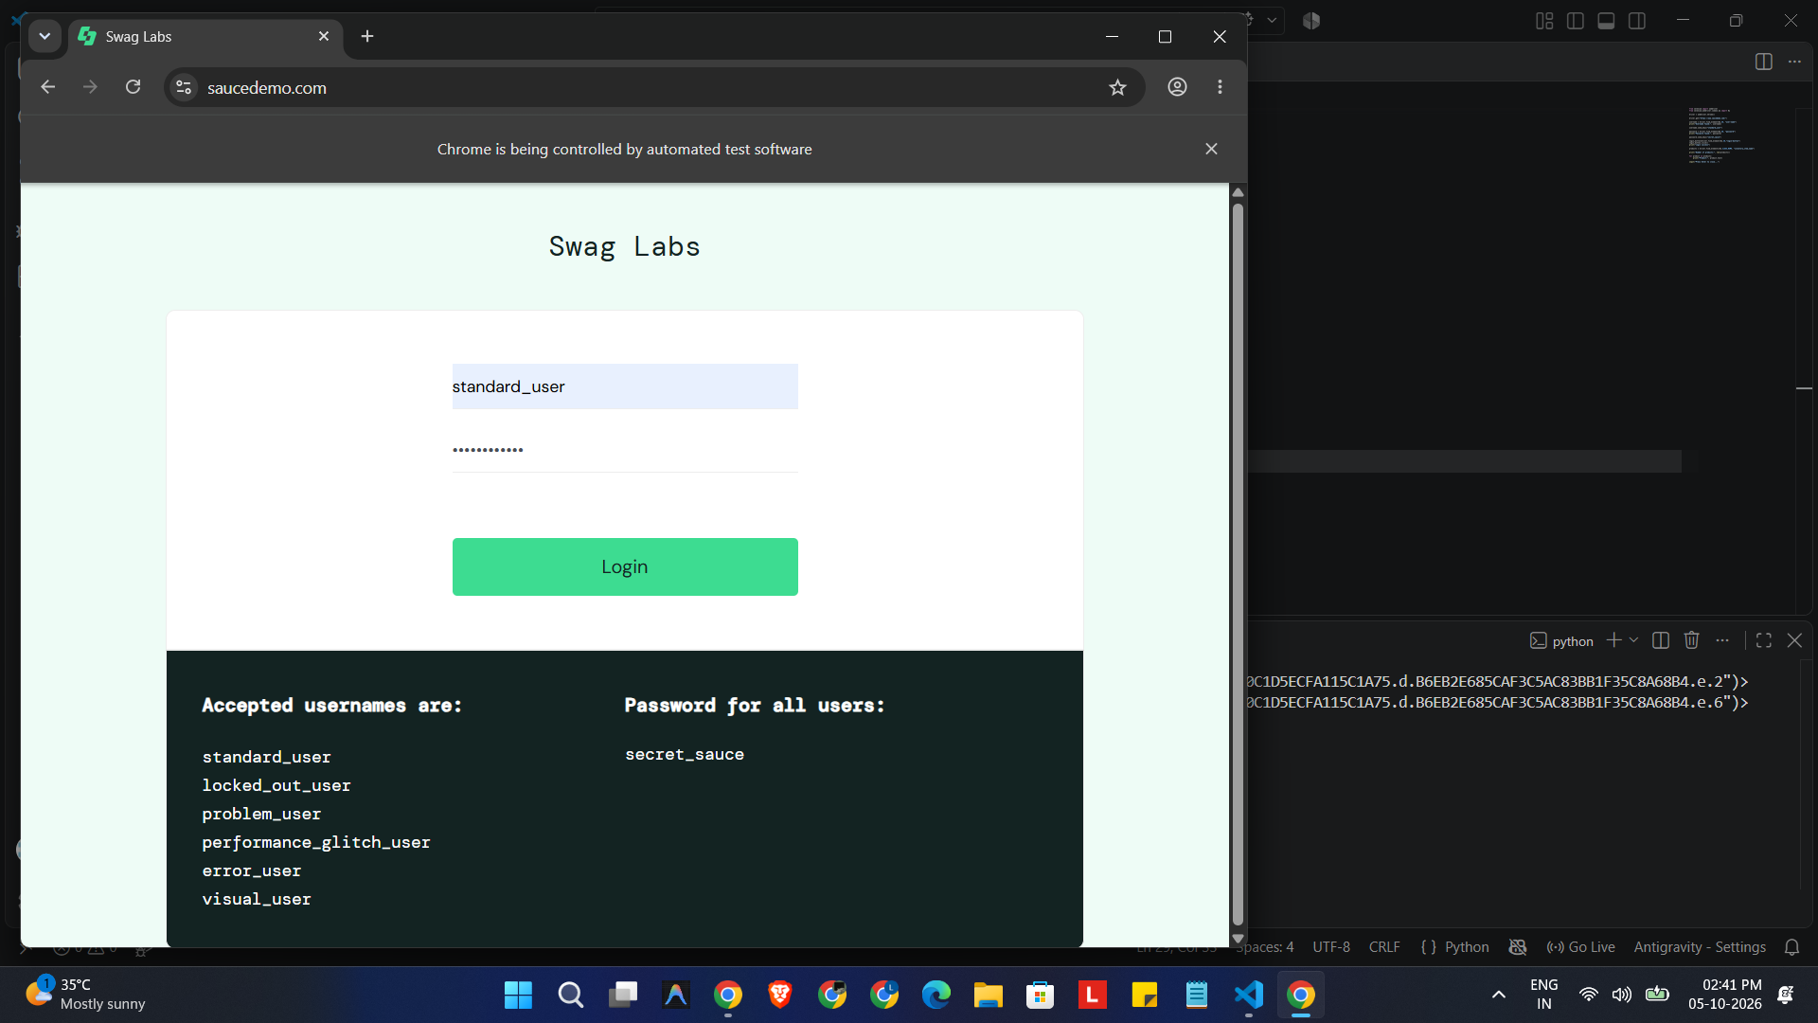
02 | Products Page
Screenshot showing the SauceDemo Products page after successful login.
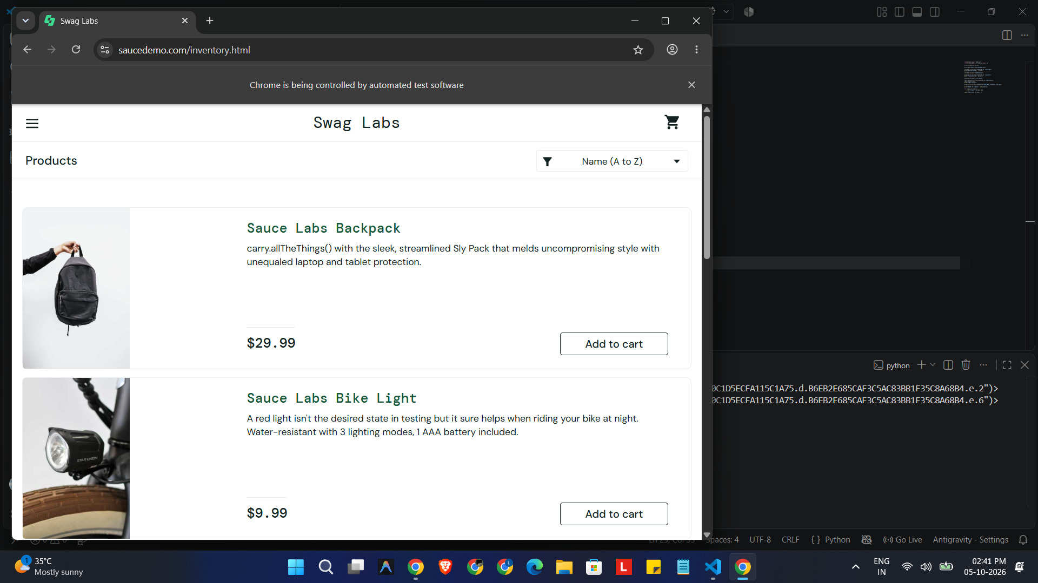
03 | Console Output
Screenshot showing the extracted list of 6 product names.
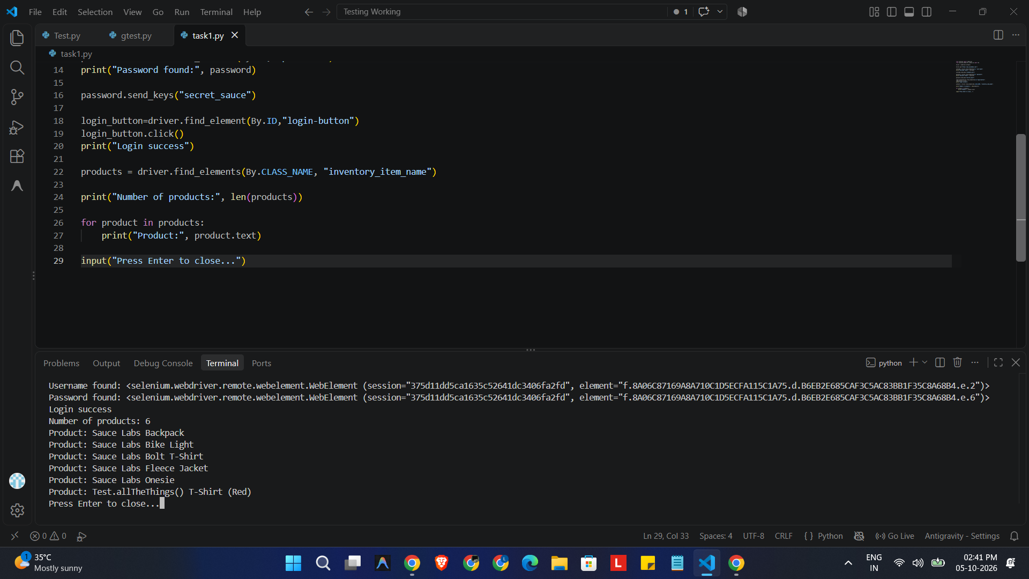
7. Result
✓ SUCCESS
Successfully automated the SauceDemo login process and extracted all 6 product names using Selenium WebDriver.

